Topic 1 : GPIO Control

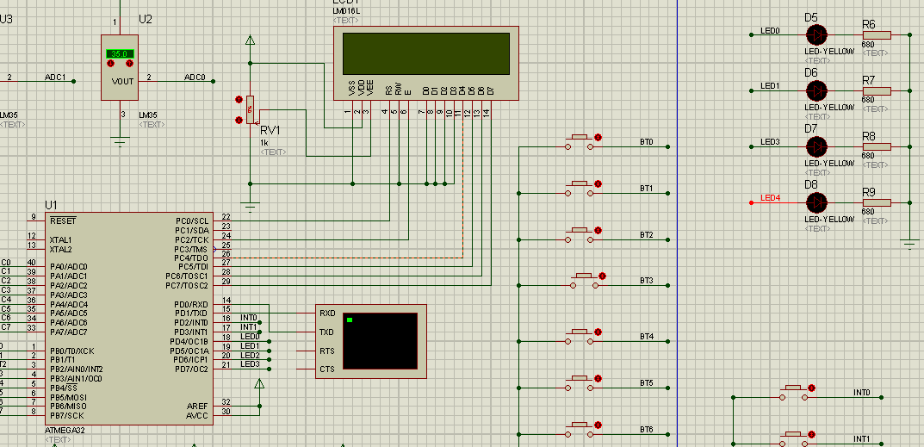

Problem 1 : Write the C program to scan the BT0, BT1, BT3,BT4 when button-x is pressed, toggle The aprropriate LED0,LED1, LED3 and LED4.

Problem 2 : Convert the C Code in Problem 1 into Assembly Code